Software Development for Mobile Devices

# Submission for Assignment A7.2C

## Navigation Model

In this task, I will create a navigation model of Evernote application.

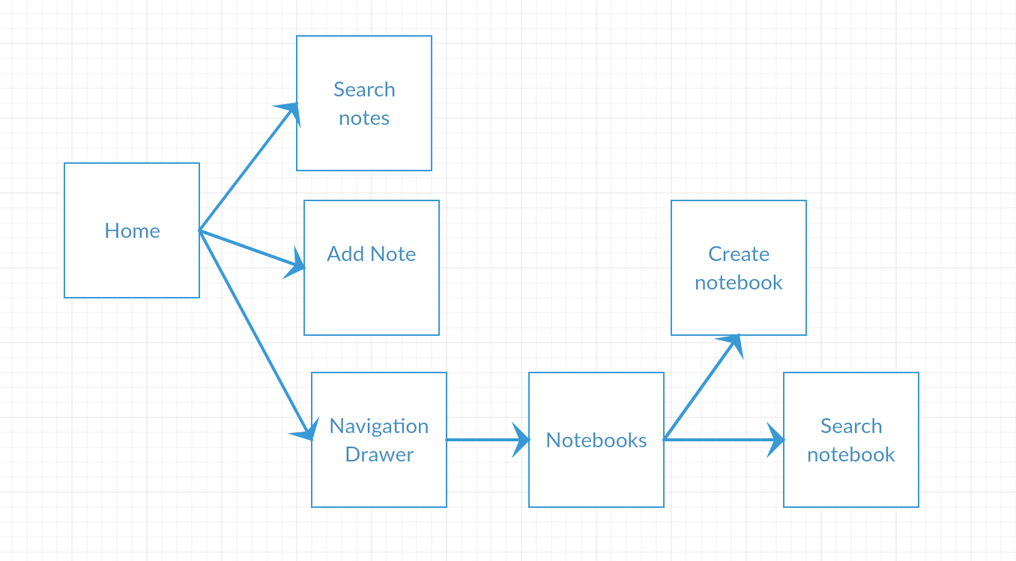

Figure : Navigation Model

## App Screen Shot

|  |  |
| --- | --- |
| Screen | Screenshot |
| Home | ../../../../../../../../Desktop/Google%20Nexus%206%20-%207.0.0%20-%20API%2024%20-%201440x2560/screensho |
| Search Notes | ../../../../../../../../Desktop/Google%20Nexus%206%20-%207.0.0%20-%20API%2024%20-%201440x2560/screensho |
| Add Note | ../../../../../../../../Desktop/Google%20Nexus%206%20-%207.0.0%20-%20API%2024%20-%201440x2560/screensh |
| Navigation Drawer | ../../../../../../../../Desktop/Google%20Nexus%206%20-%207.0.0%20-%20API%2024%20-%201440x2560/screensho |
| Notebooks | ../../../../../../../../Desktop/Google%20Nexus%206%20-%207.0.0%20-%20API%2024%20-%201440x2560/screensho |
| Create notebook | ../../../../../../../../Desktop/Google%20Nexus%206%20-%207.0.0%20-%20API%2024%20-%201440x2560/screensh |
| Search notebook | ../../../../../../../../Desktop/Google%20Nexus%206%20-%207.0.0%20-%20API%2024%20-%201440x2560/screensho |

## Evaluate the navigation

The design of the app is really good with the material designs. Nevertheless, there are some drawbacks with the navigation. Firstly, the users cannot open the notebook in the home screen but they select navigation drawer to go the notebook. Secondly, after the users go into the edit note screen from the search note, they cannot go back to home screen immediately by clicking back button. When clicking back button, they will be prompt back to the search note screen rather than the home screen.